**Ideation Phase**

# Brainstorm & Idea Prioritization

|  |  |
| --- | --- |
| Date | 19 June 2025 |
| Team ID | LTVIP2025TMID48554 |
| Project Name | ShopSmart: Your Digital Grocery Store Experience |

## Step-1: Team Gathering, Collaboration and Select the Problem Statement

Our team of four members collaboratively discussed various real-world problems in the grocery sector. We identified key challenges faced by customers and sellers. After analyzing the feasibility and impact of various options, we selected the problem statement:  
"How might we provide a seamless digital platform for users to shop groceries anytime, especially during non-working store hours?".

## Step-2: Brainstorm, Idea Listing and Grouping

**Ideas Generated:**

1. Enable users to order groceries online through a web/mobile app.  
2. Allow role-based access for customers, sellers, and administrators.  
3. Real-time cart updates and inventory tracking.  
4. Admin dashboard for system monitoring and seller approval.  
5. Smart filters for quick product search (by category, price).  
6. Support multiple payment methods including COD.  
7. Notification system via SMS/email for order updates.  
8. Delivery tracking system for users.  
9. Separate dashboards for seller and admin roles.  
 **Grouped Under:**

• User Convenience: Smart filters, easy cart, delivery tracking.  
• Admin Control: Admin dashboard, seller approvals.  
• Real-time Updates: Cart, order, and product changes in real-time.

## Step-3: Idea Prioritization

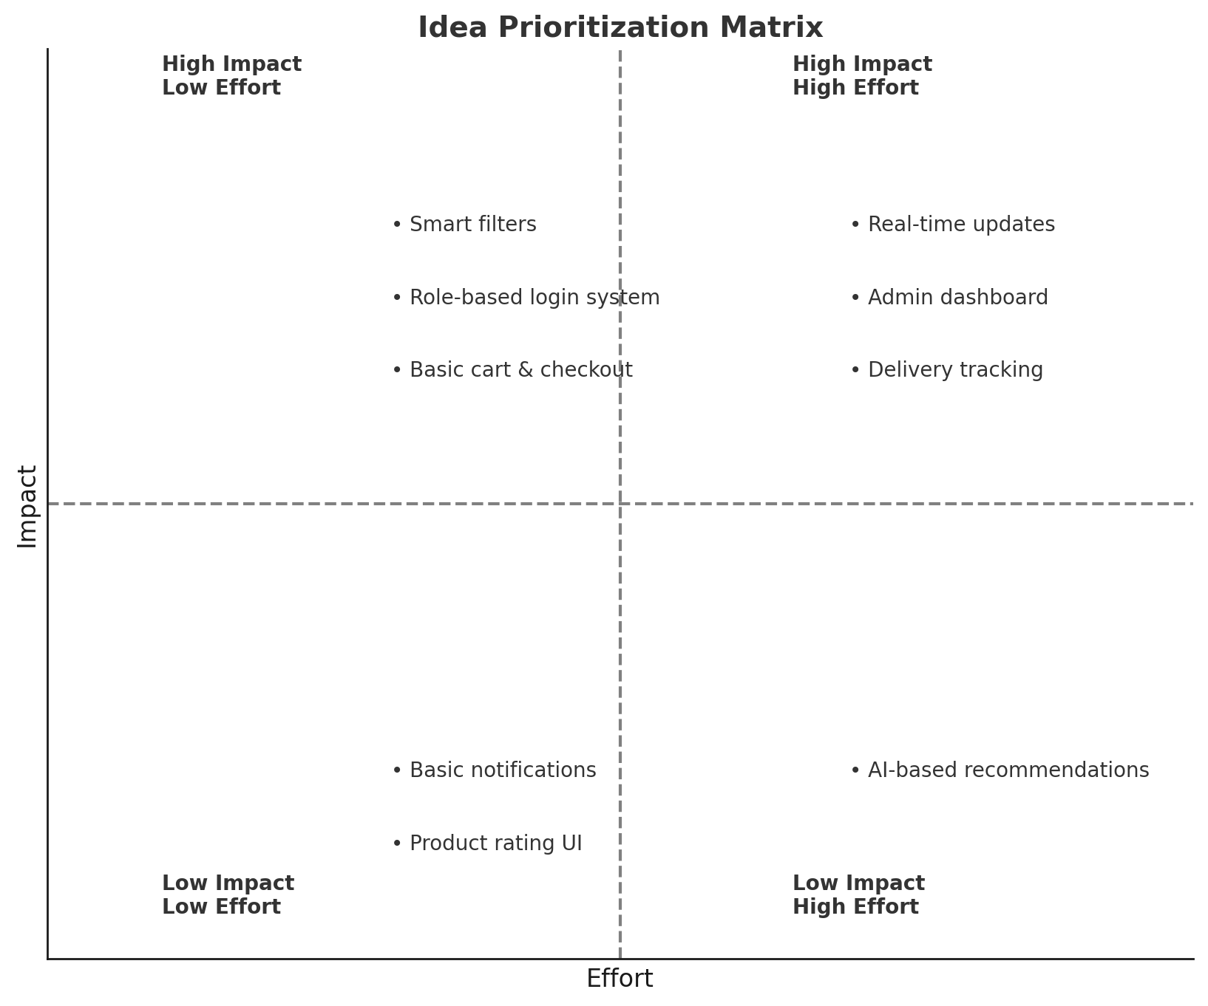

**Prioritization Matrix (Impact vs. Effort):**  
  
High Impact - Low Effort:  
• Smart filters  
• Role-based login system  
• Basic cart & checkout  
  
High Impact - High Effort:  
• Real-time updates  
• Admin dashboard  
• Delivery tracking  
  
Low Impact - Low Effort:  
• Basic notifications  
• Product rating UI  
  
Low Impact - High Effort:  
• AI-based recommendations (Future enhancement)